Newton’s 2nd Law
Horizontal
Equipment Needed

Dell Laptop Computer
AC Adapter, Dell Laptop
Mass and Hanger Set, ME-8967
Air Supply, Pasco SF-9216
Air Track, Pasco SF-9214
Air Track Accessory Kit, Pasco SF-9295
Glider, for Air Track Pasco SF-6306
LabQuest Mini, Vernier LQ-MINI
Ringstand, Miniature
String, Black (in drawer)
Photogate, Vernier VPG-DG

Purpose
The purpose of this experiment is to investigate Newton's 2nd Law of Motion with an air track. A small mass (m) will hang over a pulley at the end of the air track and will pull a glider of mass (M) along the length of the air track. It can be shown from Newton's 2nd Law that the acceleration a is given by the equation:
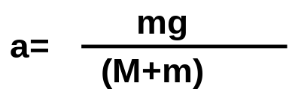

Equation 1

where mg is the force (weight) on the system that is made up of the glider and hanging mass.
Figure 1
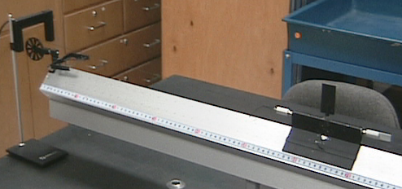

Figure 2
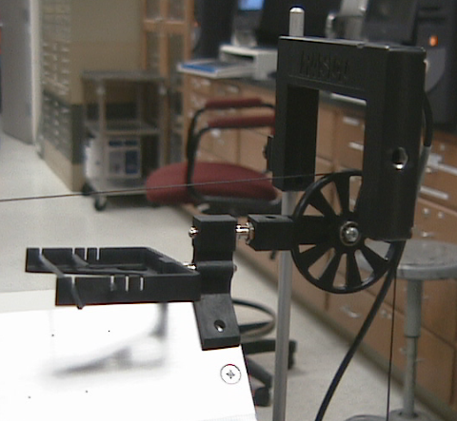

Procedure
- Set up the apparatus as shown in Figure 1 above. Arrange the photogate such that it is blocked and unblocked by the pulley as in Figure 2.
- In the menu click on ‘File’. Click ‘Open’. The file you need is under Experiments\Probes & Sensors\Photogates\Pulley.cmbl. If setup is properly wired a window will open. When window opens up click ‘Connect.’ This enables the photogate. The ‘Collect’ button should turn green.
- Balance the air track by following procedure given by your instructor. Set up the system with the hanging mass (m) at least 20g. Attach a string (about 1.5m long) to it and to the glider. The hook accessory is attached to one end of the glider (balanced by some other accessory on the other end of the glider). The mass of the glider with accessories is M.
- This step works best with 2 people. One will move the glider backwards until the mass hanger almost touches the pulley. Then the other will click the ‘Collect’ button . When the ‘Collect’ button changes to ‘Stop’ the first person will release the cart. The mass hanger will fall downward pulling the glider along the air track. Click the ‘Stop’ button to stop timing before the glider reaches the end of the track.
- The computer will then display a Velocity vs. Time graph where the slope is the acceleration of the system. Next, go to Analyze on the menu bar and go down to Linear Fit. The computer will then display a linear equation from which you can get the slope. The value of slope is your experimental acceleration.
- Compare the theoretical acceleration (found from Equation 1) with the actual measured acceleration and calculate a % error.
- Increase the hanging mass and repeat the above procedure.

DATA

Part 1: Hanging mass 20g.
Hanging Mass, m = _________grams

Mass of glider, M = ___________ grams

Accepted acceleration, 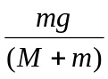= __________cm/s²

Experimental acceleration = slope of velocity vs. time graph ____________ cm/s²

% Error = 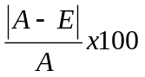= ___________%

Part 2: Hanging mass 30g.
Hanging Mass, m = _________grams

Mass of glider, M = ___________ grams

Accepted acceleration, = __________cm/s²

Experimental acceleration = slope of velocity vs. time graph ____________ cm/s²

% Error = = ___________%
- Your instructor may want you to create a chart using other masses to collect further data.
- Increase the mass of the glider and repeat the data collection procedure outlined above.

DATA

Part 3: Add 100g. mass to glider. Use constant hanging mass.
Hanging Mass, m = _________grams

Mass of glider, M = ___________ grams

Accepted acceleration, = __________cm/s²

Experimental acceleration = slope of velocity vs. time graph ____________ cm/s²

% Error = = ___________%

Part 4: Add another 100g. to glider for a total of 200g. added. Use same hanging mass as you used in Part 3.
Hanging Mass, m = _________grams

Mass of glider, M = ___________ grams

Accepted acceleration, = __________cm/s²

Experimental acceleration = slope of velocity vs. time graph ____________ cm/s²

% Error = = ___________%

